Exercise 4:
Employee Management System

1.Understand Array Representation:

how arrays are represented in memory and their advantages.
When you create an array, you are asking the operating system for a single, unbroken block of memory, which is known as contiguous memory allocation. For example, if you create an array of five integers, the computer finds a space large enough to fit exactly five integers right side-by-side. If the first item starts at memory address 1000, the next is located at 1004, followed by 1008, and so on.
This setup gives arrays two massive advantages. First, it allows for instant access running at $O(1)$ efficiency. Because the memory is unbroken, the computer uses simple math to find any item instantly. If you need the 500th employee, the CPU doesn't count from 1 to 500; it just calculates $\text{Starting Address} + (500 \times \text{Size of Item})$ and jumps directly there in a single step. Second, this layout offers incredible cache friendliness. Modern CPUs process data in chunks rather than one single byte at a time. Because arrays are packed tightly together, the CPU can grab a large portion of the array and load it into its ultra-fast hardware cache all at once, drastically speeding up execution.

2. Setup:
We will implement this in Java. Create a new file named Employee.java and a Manager for it.
Working with a raw array means we have to manually manage its strict size limit and manually shift data around when we delete an employee so we don't leave an empty "hole" in our contiguous memory block.

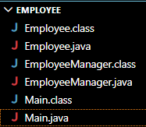

3.Implementation:
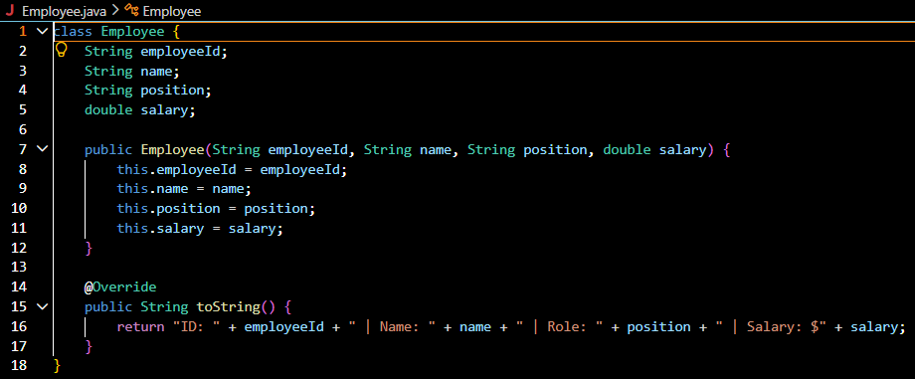
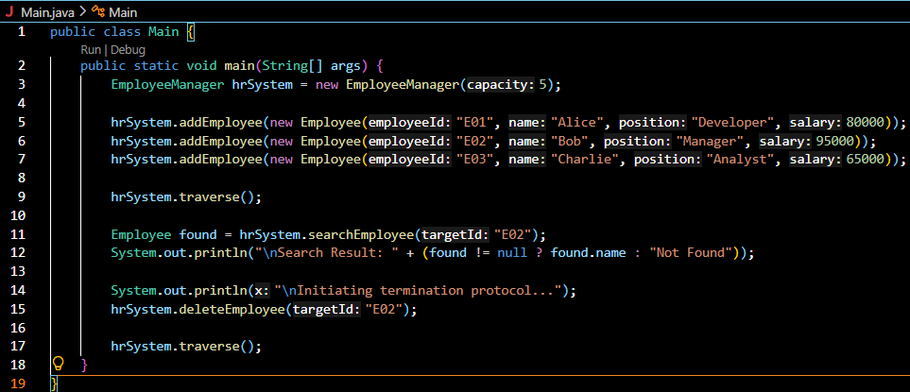
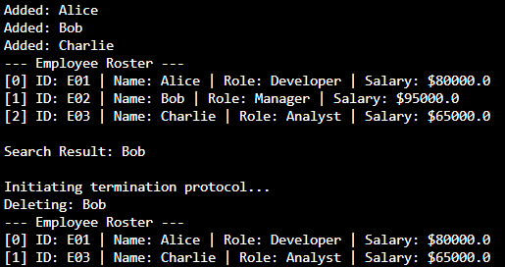
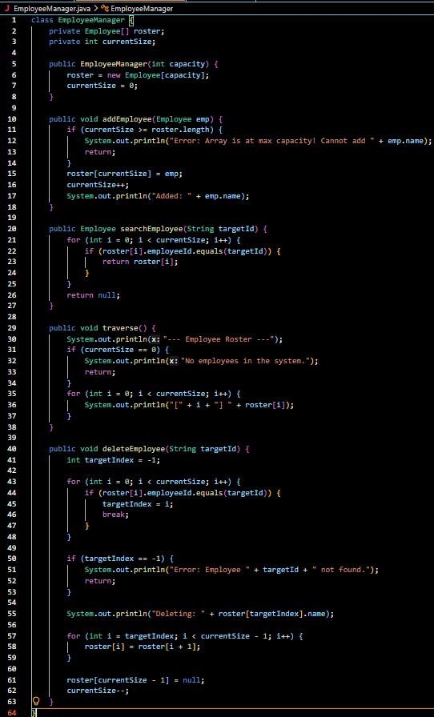

4.Analysis:
Operation | Time Complexity
Add (Append) | O(1)
Search (by ID) | O(n)
Traverse | O(n)
Delete (by ID) | O(n)

Limitations of Arrays
While arrays are fast, they come with three major limitations. First, they have a fixed capacity, meaning you must declare their size up front. If you create an array for 500 employees and hire a 501st, the system will crash. To fix this, you have to allocate a brand-new, larger array and copy all 500 existing items over one by one, which is an expensive $O(n)$ operation.
Second, they can cause significant memory waste; if you create an array for 10,000 employees "just in case" but only hire 50, you are permanently hoarding RAM that the rest of your system cannot use. Finally, arrays make for expensive modifications. Inserting or deleting an element right in the middle of an array forces a cascading shift of data, as every subsequent item has to slide over to open up or close a memory slot.
When to Use Raw Arrays
Because of these constraints, you should use raw arrays primarily when you know the exact amount of data in advance—such as the days of the week or fixed pixel dimensions on a screen—and when you plan to read the data heavily but rarely modify its length. For dynamic data that changes constantly, like a growing corporate roster, modern systems typically wrap arrays into dynamically resizing classes like Java's ArrayList, or switch to structures like Linked Lists and Databases.

